TIES 452 (2014): Guidelines for the 1st computer class demo

Your surname: Khandker
Your first name: Syed Ibrahim

Task 1: Below is RDF data written in N-triples notation. Rewrite it to Turtle notation. Do not use full URIs (e.g. http://family.com/family/hasAge). Instead of that use qnames (e.g. fam:hasAge) to save space.

Tip: You can use commas (,), semicolons (;), and other abbreviations to save space.

Data in N-triples:
<http://www.smith-family.com/family#Peter> <http://www.smith-family.com/family#hasChild> <http://www.smith-family.com/family#Jane> . <http://www.smith-family.com/family#Peter> <http://www.smith-family.com/family#hasSon> <http://www.smith-family.com/family#Adam> . <http://www.smith-family.com/family#Peter> <http://www.smith-family.com/family#hasFirstname> "Peter" . <http://www.smith-family.com/family#Peter> <http://www.smith-family.com/family#hasSurname> "Smith" . <http://www.smith-family.com/family#Peter> <http://www.smith-family.com/family#hasAge> "67" . <http://www.smith-family.com/family#Jessica> <http://www.smith-family.com/family#hasHusband> <http://www.smith-family.com/family#Adam> . <http://www.smith-family.com/family#Jessica> <http://www.smith-family.com/family#hasChild> <http://www.smith-family.com/family#Bill> .

Solution in Turtle:
@prefix S: <http://www.smith-family.com/family#>.

S:Peter S:hasChild S:Jane; S:hasSon S:Adam; S:hasFirstname "Peter"; S:hasSurname "Smith"; S: hasAge "67".

S: Jessica S: hasHusband S:Adam; S:hasChild S:Bill.

Task 2: Below there is a graph representing RDF data. Rewrite this graph in Turtle notation. Same as in task 1, use qnames, commas (,), semicolons (;) and other abbreviations to save space.

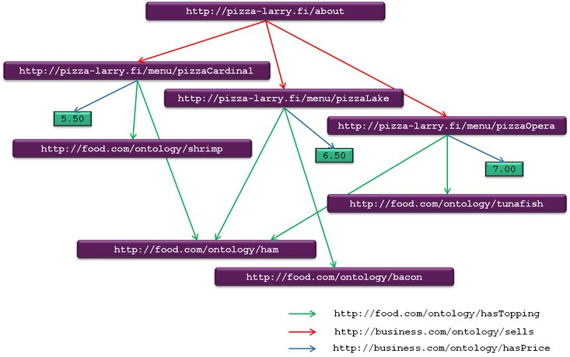
Solution in Turtle:
@prefix A: <http://pizza-larry.fi/>
@prefix I: <http://pizza-larry.fi/menu/>
@prefix S: <http://business.com/ontology/>
@prefix T: <http://food.com/ontoloty/>

A:about S: Sells I: pizzaCardinal, I: pizzaLake, I: pizzaOpera.

I: pizzaCardinal T:hasTopping T:shrimp, T: ham; S:hasPrice "5.50".

I: pizzaLake T:hasTopping T:bacon, T: ham; S:hasPrice "6.50".

I: pizzaOpera T:hasTopping T:shrimp, T: ham; S:hasPrice "7.00".

Task 3: Below you can find RDF data written in Turtle notation. Draw an RDF graph that represents this data. You can use any drawing tool you want. It is highly recommended to use some tools that can draw diagrams (e.g. Inkscape, Corel Draw, Microsoft Visio, etc.). Also Microsoft Powerpoint has the option of drawing vector diagrams. There is a “toolkit” provided at http://users.jyu.fi/~olkhriye/ties542/demos/demo1/toolkit.ppt. After drawing the picture, insert it into this document.

Important: Please do not insert big images. Try to resize the image and convert it to compressed formats like PNG or JPG (not BMP!).

Data in Turtle:
@prefix a: <http://www.books.com/authors/> .
@prefix b: <http://www.books.com/books/> .
@prefix n: <http://www.world.com/nationality/> .
@prefix rdf: <http://www.w3.org/1999/02/22-rdf-syntax-ns#> .

b:hp1 a b:Book , b:FantasyBook ; b:hasTitle "Harry Potter and the Sorcerer's Stone" ; b:hasAuthor a:jkr ; b:hasSequel b:hp2 ; b:isAbout [ a a:Sorcerer ] .

a:jkr a a:Author ; a:firstname "Joanne" ; a:middlename "Kathleen" ; a:surname "Rowling" ; a:nationality n:GB .

HERE PASTE YOUR GRAPH

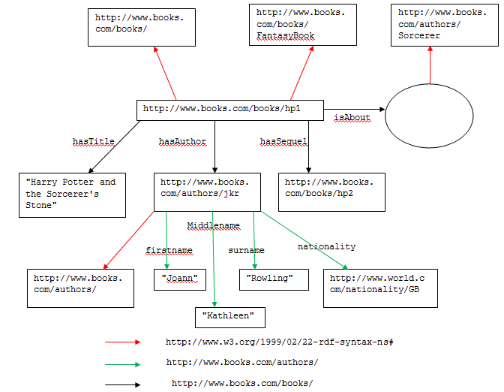

Files to include in the demo results:
- Demo1-instructions.doc (this file)

Send the demo results as an archive to lecturer (oleksiy . khriyenko @ jyu . fi) before the next Demo session.

